

**Bitcoin price factors – A Comparative study of what influences the Bitcoin price most?**

**Submitted by :** Jitendra Upadhyay (11910012) | ISB CBA Practicum

**Date of Submission :** 24/06/2018

**Table of Contents**

**Executive Summary** **2**

**Business Problem** **2**

**Introduction** **2**

**Motivation for the study** **2**

**Questions & Hypothesis** **3**

**Methodology & Tools** **3**

**Data Collection & Cleaning** **3**

**Analysis & Results** **4**

**Robustness Tests** **8**

**Conclusion** **8**

**Recommendations and business solution** **8**

**Feasibility and Limitations** **8**

**Appendix 1: Impact on Related Product Lines** **9**

**Appendix 2: TESTS on Other Cases** **10**

**References** **12**

**PAGE 1**

**Executive Summary**

**The Bitcoin has emerged as a ravishing phenomenon in the Financial markets without any central authority issuing the currency, the Bitcoin has been associated with controversy ever since its popularity, accompanied by increased public interest, reached high levels. In this paper I am contributing to the discussion by examining the potential drivers of Bitcoin prices, ranging from fundamental sources to formulized and technical ones, and we further study the potential influence of the bitcoin in financial market using time series analysis and influence of Social media by determining the collective mood derived from twitter feeds.**

**The progression of the relationships is examined in both time and frequency domains utilizing the continuous wavelets framework, so that we not only comment on the development of the interconnections in time but also distinguish between short-term and long-term connections. We find that the Bitcoin forms a unique asset possessing properties of both a standard financial asset and an ideological one.**

**BUSINESS PROBLEM**

**To analyze the sentiments for cryptocurrency in general and compare the sentiments and**

**prices across the cryptocurrencies.**

**Analyze the articles, opinions, researches and understand the perspective of different stakeholders- regulators, exchanges, financial institutions, experts, investors and public.**

**Identify the factors that are driving the market and influencing the stakeholders.**

**Analyze the growth of cryptocurrency market- overall and regional level.**

**INTRODUCTION**

**The Bitcoin is a from of digital currency which has been emerged during the recent years which has got peer to peer system to expedite transactions.**

**Its is not govern by any central bank of leading financial institutions but uses of cryptographic methods total relies on an open source software algorithms which verifies and verifies propogate transactions and controls the creation of new Bitcoins.**

**The large inconstancy of Bitcoin prices especially during the year of 2013 and the huge increase in the subsidization of the associated market have given rise to a branch of the literature studying the factors which help to explain or predict the value of Bitcoins more accurately and hence influence the decision making capabilities of the traders to invest in this form of market.**

**In this project , the main area of focus is to study and perform the exploratory data analytics on the dynamics governing the formation of Bitcoin prices by focusing on Twitter sentiment as an explanatory factor along with other economic and technological variables.**

**MOTIVATION FOR THE STUDY**

**In this context, the impact of data mining technology – which affects the production cost structure and thus the supply side of the market – on Bitcoin prices .**

**The standard economic theory is not sufficient to justify the changes and the root cause of fluctuation within the Bitcoin prices and one should not take any short run speculation based upon investment incentives ,however there are multiple factor which expedite the price structure of cryptocurrency so the effort has been made to measure the public mood and study its impact on the evolution of Bitcoin prices. In the context of comparative study**

**Have used the search queries on Google trends and wiki trends to understand the public sentiments and find the positive correlation between the measures and the price of bitcoin.**

**We extend the above line of corollary here by constructing a sentiment ratio for Twitter users on a basis of Hash tags of different tweets.**

**PAGE 2**

**QUESTIONS & HYPOTHESIS**

**Following are some of the key questions/ hypothesis that we would like to answer/ test:**

1. **Does sentimental classification play any significant role in determining the price of bitcoins?**
2. **What are the economic drivers of Bitcoin price index?**
3. **Influence of econometric parameters on bitcoin.**
4. **What are the types of crypto currencies are more safer to transits.**

**METHODOLOGY & TOOLS**

If we consider Bitcoin as a medium of exchange then the following equation is governing the exchange associated with the quantity theory of the money stipulates **MV=PT**

M 🡪 Nominal supply of money,

V 🡪 Velocity of money circulation,

P 🡪 The general price level,

T 🡪 The size of the underlying economy

The nominal supply of Bitcoins is given by **M=PBB**

where PB 🡪 the price of Bitcoins and B 🡪 the stock of Bitcoins in circulation, thus implying **PB=PT/VB**.

**DATA COLLECTION & CLEANING**

**Google Trends and Yahoo Finance were predominantly used as data source for this study.**

1. We collected and analyzed a set of over 2,000+ tweets during a time period of 8 days. The data collection process focused on collecting tweets for the keywords "Bitcoin", "BTC" and “Bitcoins" along with their respective hashtags "#Bitcoin", "#BTC", "#Bitcoins". This task was accomplished by parsing the official streaming API of Twitter with Python (pytweet).
2. www.quandl.com is another platform provides a straightforward way to extract the information from the first site,
3. Blockchain.info distinguish between three types of platform descriptors: currency statistics, block details, mining information, network activity and blockchain wallet activity, all the variables within such categories have a daily frequency of different crypto Rates.

**ANALYSIS & RESULTS**

1. **Bitcoin price forecast using Facebook prophet Library:**

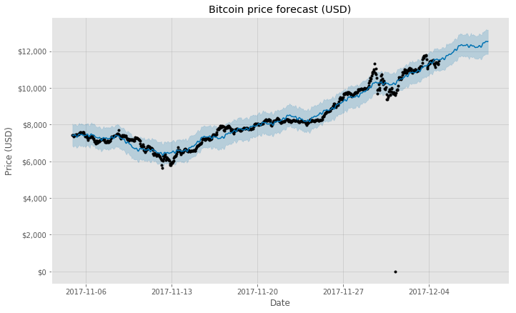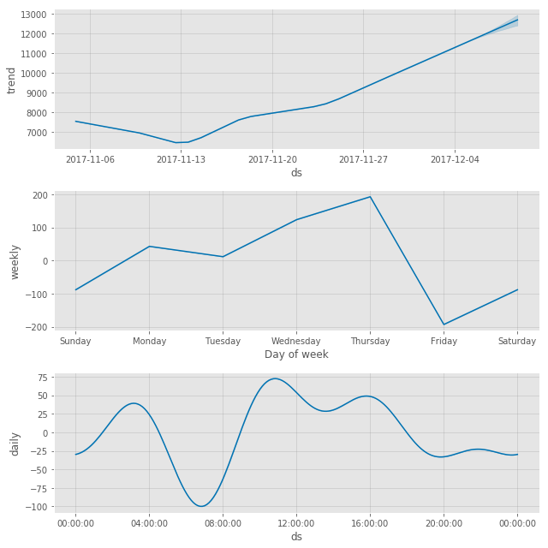

1. Quantifying trading behavior in financial market(bitcoin transaction) using Google Trends.
2. 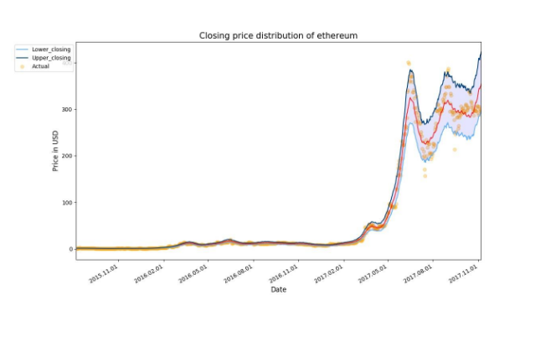

**CONCLUSION**

This Project tries to throw a light on the external factor which eventually determine the price of the bitcoins in short as well in long runs .We built an observational model incorporating multiple economic and external technological variables but also extended the existing classics by taking Twitter sentiment into account.

By measuring the sentiment ratio of Twitter users concerning Bitcoins on a daily basis. After proceedings with issues of static and conjuration, we estimated several regression models indicating that our Twitter sentiment ratio has a +ve short-run impact on Bitcoin prices. In other words, evidence shows that measurements of concentrated mood based on the appropriate sentiment analysis can help to predict short-run movements in the value of Bitcoins. Furthermore, the price of Bitcoins has been found to be positively affected by the number of Wikipedia search queries. This implies that a higher degree of public appreciation and interest in Bitcoins increases their market price. Similarly, an increase in the # hash rate has a positive effect on Bitcoin prices.

**RECOMMENDATIONS AND BUSINESS SOLUTION**

**The Result clearly depict that public mood is associated with online social media and hence been infer to predict the moment of stock market index. It has also been depicted that that Twitter posts (related to Bitcoins) which express negative sentiments or uncertainty are negatively correlated with the price of Bitcoins. In this project, we perform sentiment analysis through the use of a machine learning algorithm (using SVM).**

**The econometric analysis of out time series also implies that the twitter sentiment ration has a major role and prominent impact on bitcoin process additionally the frequency of Wiki views depict the level of data mining difficult as well.**

**FEASIBILITY AND LIMITATIONS**

To predict the future price of cryptocurrencies is much trivial that it than it looks. We have tried Various available API :Facebook Prophet, HMM and PCA-SVM-FBProphet .There is always a scope of improvisation in the exploratory data analytics.

**REFERENCES**

<https://arxiv.org/ftp/arxiv/papers/1706/1706.01437.pdf>

Exploring the determinants of Bitcoin’s price: an application of Bayesian Structural

<https://medium.com/@joshua_e_k/forecasting-bitcoin-prices-using-facebooks-prophet-library-9cfce74e414c>

<https://pdfs.semanticscholar.org/05f3/7fcb95488402bb9e4d0d5a291e1338de41a6.pdf>

**PAGE 12**